The ruler is divided into twelve inches. The typical ruler is broken into one sixteenths of an inch. Each inch has sixteen equal spaces.

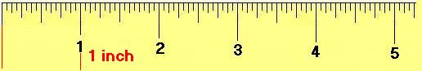
All whole numbers represent inches.
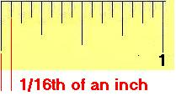 | One space is equal to 1/16th of an inch. The one sixteenth inch line indicators are shorter than the one eighth inch line indicators.
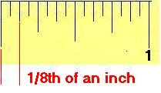 | Two spaces are equal to 1/8th of an inch. The one eighth inch line indicators are shorter than the one quarter inch line indicators.
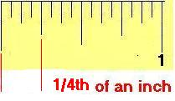 | Four spaces are equal to 1/4 of an inch. The one quarter inch line indicators are shorter than the one half inch line indicators.
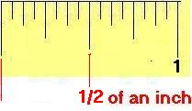 | Eight spaces are equal to 1/2 of an inch. The half inch line indicators are the longest lines other than the full one inch marks.
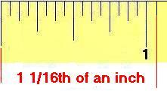 | Once an inch marker is passed, the whole number is placed before the fraction.

